**TYPE 1**

1. On your visit to Stonehenge u found an ancient code of numbers. Decode the code (73,84,67,88,71,91,67,84,70) if 'DEMISE' is (70,71,79,75,85,71

ANSWER: GRAVEYARD

1. A hot liquid is kept a ‘big room’. The logarithm of the numerical value of the temperature difference between the liquid and the room is plotted against time. The shape of the plot will be very nearly?

Answer: straight

1. 0.75 gram of petroleum was burnt in a bomb calorimeter which contains 2kg of water equivalent 500 gram. The rise in the temperature was 30C. The calorific value of petroleum is 10nN. What is the value of n?
   1. ANSWER: 4
2. Two spherical bodies A (radius of 6 cm) and B (radius 18cm) are at temperatures T1 and T2 respectively. The maximum intensity in the emission spectrum of A is at 500nm and in B is 1500nm. Considering them to be black bodies, what will be the ratio of the rate of total energy radiated by A to that of B?
   1. ANSWER: 9
3. On a new scale of temperature (which is linear) and called the W scale, the freezing and boiling point of water are 390 W and 2390 W respectively. What will be the temperature on the new scale, corresponding to a temperature of 390 C on the Celsius scale?
   1. ANSWER: 1170 W
4. The mesmerizing view from the top floor of the empire state building left you speechless and then you notice an experiment being conducted by two students. A person A throws a ball from the top of Empire State, at a height of 400m from the ground, another person B throws a ball at the same time in the air at a speed of 100 m/sec. Find the distance covered by ball B after it crosses ball A. (assume g=10 m/sec2).

ANSWER: 480 m

1. You had some free time and you planned to visit a nearby water park. There you observed a system of pipes of circular cross section:

A pipe A has a discharge of 50 m3/s. It is divided into two parts B and C, B has a velocity of10 m/s and diameter of 1 m. C is further divided in to D and E. And finally E and B meets giving a final discharge of 40 m3/s.Find the discharge in D. Neglect friction and other losses and round off the answer to the nearest whole number

ANSWER : 9 or 10 or 11

1. Being an engineer, a structural engineer consulted you to help out with a technical trouble he was facing. Find the position of the centroid of the given figure about AB. Take A as the origin. Answer in the format <X>,<Y>

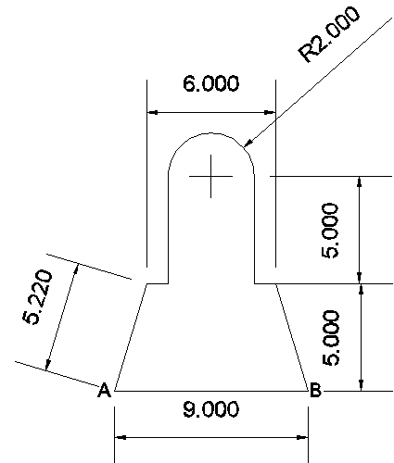

ANSWER: X=4.5, Y=4.79

1. On your way to 30 St. Mary Axe you passed by BIG BEN, you noticed that the time was 10:20, after visiting the 30 St Mary axe and now reaching the Big ben, you notice that the hour hand has moved by an angle 73 degrees .What is the time now? Answer in the format (hh:mm)

ANSWER: 12:46

1. A particle moves in a region having a uniform magnetic field and a parallel uniform electric field. At some instant, the velocity of the particle is perpendicular to the field direction. The path of the particle will be ?

ANSWER: a circle

1. Displacement current goes on through the gap between the plates of the capacitor when the charge in the capacitor________

ANSWER: is zero

1. A point source of light is used in a photoelectric effect. If the source is received farther from the emitting metal .What effect it will have on the stopping potential?

ANSWER: will remain constant.

1. A car is running at a speed u. Seeing a child on the road, the driver applies brakes so as to bring the car to halt within a distance S. What is the reaction time of the driver?

ANSWER: 2S/u

1. A ship is sailing westwards at 8 m/s. While trying to fix a bolt at the top of the mast, the sailor drops the bolt. If the mast of the ship is 19.6 m high, where will the bolt hit the deck?

ANSWER: at its foot

1. A cart of mass 500 kg is standing at rest on the rails. A man weighing 70 kg and running parallel to the rail track with a velocity of 100 ms-1jumps on to the cart on approaching it. Find the velocity with which the cart will start moving?

ANSWER: 1.23m/s

1. A disc of mass 10g is kept floating horizontally by throwing 10 marbles per second against it from below. If the mass of each marble is 5g, what is the velocity with which the marbles are striking the disc (cm/s). Assume that the marbles strike the disc normally and rebound normally with the same speed.

ANSWER: 98cm/s

1. A mass of 0.5 kg moving with a speed of 1.5 m/s on a horizontal smooth surface collides with a nearly weightless spring of force constant k= 50N/m. what would be the maximum compression of the spring?

ANSWER: 0.15m

1. A rocket is fired vertically from the surface of mars with a speed of 2km/s. If 20% of its initial energy is lost due to martian atmosphere resistance, how far will the rocket go from the surface of mars before returning to it? Mass of mars= 6.4x1023 kg, radius of mars= 3395km, G=6.67x10-11Nm2/kg.

ANSWER: 495km

1. A spherical drop of water carrying a charge of 3.0x10-10 has a potential of 500V at its surface. If two such drops combine to form a single drop, what is the potential at the surface of the new drop so formed?

ANSWER: 795V

1. Acc.to Newton’s law of gravitation the force acting on two bodies of mass 1kg situated at a distance of 10^-9m. the Force will be equal to

Answer: zero

1. Newton solved the apple earth problem by stating the.

Answer: shell theorem

1. A boy whirl a stone in a horizontal circle of radius 1.5m and at a height 2m above the level ground. The string breaks and the stone flies off tangentially and strikes the ground after travelling a horizontal distance of 10m. What is the magnitude of the centripetal acceleration of the stone while in circular motion?

ANSWER: 163m/s2

1. A thick uniform bar lies on a frictionless horizontal surface and is free to move in any way on the surface. Its mass is 0.16kg and length is 1.7 m. Two particles each of mass 0.8kg are moving on the same surface and towards the bar in the direction perpendicular to the bar, one with a velocity of 10m/s and other with velocity of 6m/s. If collision between the particles and the bar is completely inelastic, both particles strike with the bar simultaneously. What is the velocity of center of mass after collision?

ANSWER: 4m/s

**TYPE 2**

1. If heat is supplied to a body ,its temperature
2. Must increase c) may increase
3. May remain constant d) may decrease

ANSWER: b and c (tough)

1. A gas kept on a container of finite conductivity is suddenly compressed. The process
2. Must be very nearly adiabatic
3. Must be very nearly isothermal
4. May be very nearly adiabatic
5. May be very nearly isothemal

ANSWER: c and d

1. A rigid container of negligible heat capacity contains one mole of an ideal gas. The temperature of the gas increase by 10C if 3.0 cal of hear is added to it. The gas may be
2. Helium
3. Argon
4. Oxygen
5. Carbon dioxide

ANSWER : a and b

1. A point charge is brought to an electric field. The electric field at a nearby point
2. Will increase if the charge is positive
3. Will decrease if the charge is negative
4. May increase if the charge is positive
5. May decrease if the charge is negative

ANSWER: c and d

1. When no current is passed through a conductor
2. The free electrons do not move
3. The average speed of a free electron over a large period of time is zero
4. The average velocity of a free electron over a large period of time is zero
5. The average of the velocities of all the free electrons at an instant is zero

ANSWER: c and d

1. Two resistors having equal resistances are joined in series and a current is passed through the combination. Neglect any variation in resistance as the temperature changes. In a given time interval,
2. Equal amount of thermal energy must be produced in the resistors
3. Unequal amount of thermal energy may be produced
4. The temperature must rise equally in the resistors
5. The temperature may rise equally in the resistors

ANSWER: a and d

1. Two identical metallic spheres are given charges +q and –q respectively. Now,
2. Both the spheres have equal masses
3. The positively charged sphere has a mass smaller than the negatively charged sphere
4. The negatively charged sphere has a mass smaller than the positively charged sphere
5. The change in their masses depend upon the magnitude of q.

ANSWER: b and d

1. A planet of mass m is revolving around the sun in an elliptical orbit. If ‘v’ is the velocity of the planet when its position vector from sun r then if the planet rotates in counter clockwise direction then areal velocity has direction
2. Given by “ right hand thumb rule”
3. Given by “ left hand thumb rule”
4. Normal to the plane of the orbit upwards
5. Normal to the plane of the orbit downwards

ANSWER: a and c

1. Two cubes each weighing 22g exactly are taken. One is of iron ( d= 8x103 kg/m3)) and other is of marble (d= 38x103 kg/m3). They are immersed in alcohol and then weighed again
2. Iron cube weighs less
3. Iron cube weighs more
4. Both have equal weight
5. Nothing can be said

Answer: b

1. When a body cools by radiation the rate of cooling depends upon ( mention 5)

Answer:

1. Temperature of radiating body
2. Temperature of surroundings
3. Mass of radiating body
4. Area of radiating surface
5. Nature of radiating surface
6. Specific heat of radiating body.
7. Which of the following statement(s) is/are incorrect:

Statement a: Reversible isothermal compression of an ideal gas represents the limiting min value of the work done (|w|) by the surrounding of the system.

Statement b: In an irreversible process, the cyclic integral of work is not zero.

Statement c: For thermodynamic changes in adiabatic process. T(C,m)/RP=constant

Statement d: Ssystem is zero for reversible adiabatic expansion for an ideal gas

Codes:

1. Statement c B) Statement a,b,c C)Statement a,b,d D)all

Ans:A

1. Two old friends, Jack and Johns, meet after a long time.  
     
   Three kids  
   Jacob: Hey, how are you man?  
   John: Not bad, got married and I have three kids now.  
   Jacob: That’s awesome. How old are they?  
   John: The product of their ages is 72 and the sum of their ages is the same as your birth date.  
   Jacob: Cool… But I still don’t know.  
   John: My eldest kid just started taking piano lessons.  
   Jacob: Oh now I get it.  
     
   How old are Johns’s kids?

ANS: 3,3,8

1. You need to fill number in the bricks in the image below such that the top brick is sum of two brick below it.

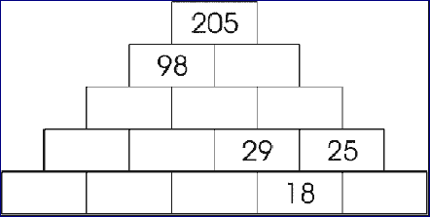

ANS:

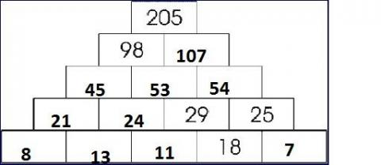

29. Distances from you to certain cities are written below.  
BERLIN 200 miles  
PARIS 300 miles  
ROME 400 miles  
AMSTERDAM 300 miles  
CARDIFF ??? miles  
How far should it be to Cardiff ?

Answer: 100 miles.

1. Select the correct option/ options
2. An object shall weigh the same at pole and equator when weighed by using a physical balance.
3. It shall weigh the same at pole and equator when weighed by using a physical balance.
4. It shall weigh the same at pole and equator when weighed by using a spring balance
5. It shall weigh the more at pole than at equator when weighed by using a spring balance.

Ans=b and d

1. Choose the wrong statements
2. Bulk modulas of elasticity is reciprocal of compressibility. (OPTION TO BE CHANGED)
3. The breaking force for a wire is F. The breaking force for a single wire of double thickness is 2F.
4. A wire stretches a certain amount under a load. If the load and the diameter of the given wire are both increased to three times , the stretch caused in the wire is 1/9 times.
5. The elastic after effect is negligible small for quartz but very large for glass fibre.
6. The possible value of Poissons ratio of a substance lies between 0 and 0.5.

Ans: b,c,e

1. When fishes move up and down in water they and to facilitate their movement
2. Choose the wrong statements
3. The molecules of the liquid lying in the surface film have smaller potential energy in comparison to the inner molecules.
4. For a curved surface of a liquid in equilibrium, the pressure is more on the concave side of the liquid than on the convex side.
5. Excess pressure inside the air bubble of radius R at the depth h inside a liquid of surface tension S is p=h*p*g+ 2*S/R*
6. Angle of contact increases with the increase in temperature of liquid.
7. Angle of contact depends on the inclination of the solid surface to the liquid surface. A,c,e
8. Choose the wrong statements
9. Temperature of a body determines, the heat contents of the body
10. The separation marks on the thermometer for freezing point of ice and boiling point of water are equal for centigrade temperature and absolute temperature scale.
11. The density of a solid changes with the rise in temperature dT by the relation

*P’*=*p*(1+*y*dT)

where *p* and *p’* is the initial and the final density of the solid and *y is the* coefficient of volume expansion of the solid.

1. Specific heat of water always increases with rise in temperature upto boiling point of water.

Ans a,c,d